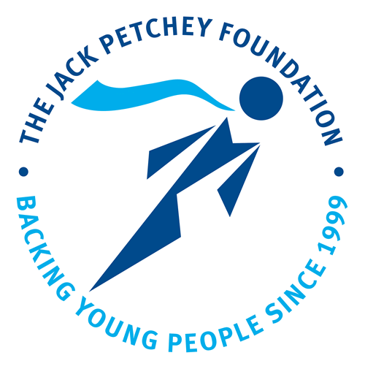
Jack Petchey Achievement Award Nomination

The Jack Petchey Achievement Award Scheme enables Plume Academy to recognise, reward and celebrate the achievements of students who show great pride in what they do, or have contributed to the Academy or local community in a significant way.

Whether this is through being an excellent role model, overcoming personal adversity, volunteering to help others or showing great dedication for example to sport, music or art, we want to know about it.

I wish to nominate: ____________________________ Date: Spring 2025

My name is: _________________________________________________________________

Position in organisation: ______________________________________________________
(e.g. club member/student /staff member /parent /governor etc.)
Reason(s) for nomination:

Signature: Date:
If you wish to obtain the support of others:
Name: Signature: Date:
Name: Signature: Date:
Name: Signature: Date:
Achievement Award Winners will receive a framed certificate, a pin badge, a boxed medallion and £300 to be spent on a project of their choice which will benefit a group of young people.
Please complete this form and return to B Collen
Deadline April 4th

